Halloween | Name: | Class: | Date:

1
You need
2-4 players
1 token for 1 player
1 Gameboard
12 Picture Cards
12 Question Cards
1 dice

2
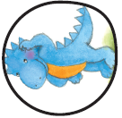
Take a question card.
Read and answer the question.
OK? Keep the card.
Wrong? Lay the card back.

3

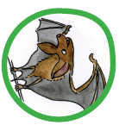
Take a picture Card. Say the word.
OK? Keep the card.
Wrong? Lay the card back.

4
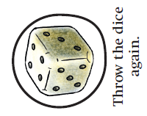
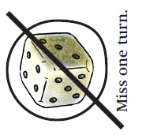

5

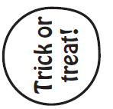
Finish! Count your cards.

