 | Name | Klasse | Datum |  | KV 1

Back to school

1
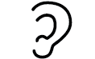
Listen and match.
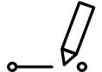
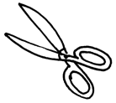 | 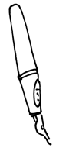 | 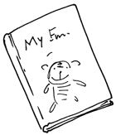 | 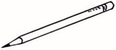 | 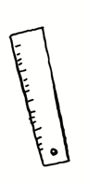 | 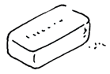 | 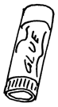 | 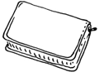
○ | ○ | ○ | ○ | ○ | ○ | ○ | ○
○ | ○ | ○ | ○ | ○ | ○ | ○ | ○
book | scissors | pen | rubber | pencil | ruler | pencil case | glue stick

?
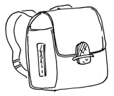
2
What’s in their schoolbags? Listen and match.

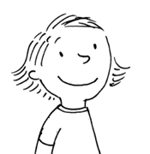 |  | 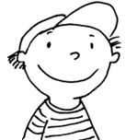 |  | 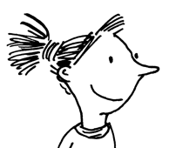 |  | 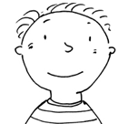
Anne |  | Tom |  | Ellen |  | Ben
○ |  | ○ |  | ○ |  | ○
○ |  | ○ |  | ○ |  | ○
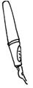  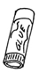  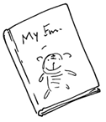 |  | 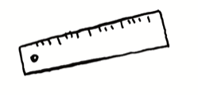  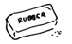   |  | 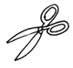  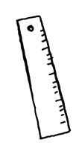 |  | 