 | Name: | Klasse: | Datum: |  | KV XXX
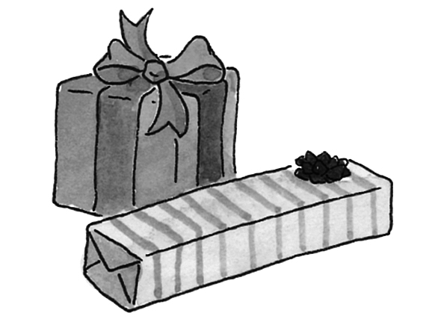

Was da wohl drin ist?

