 | Name: | Klasse: | Datum: |  | KV 8
 | Bildsachaufgaben (Station 5)

3 + 3 = ___ | 6 – 3 = ___
7 + 3 = ___ | 10 – 3 = ___
9 + 3 = ___ | 12 – 3 = ___

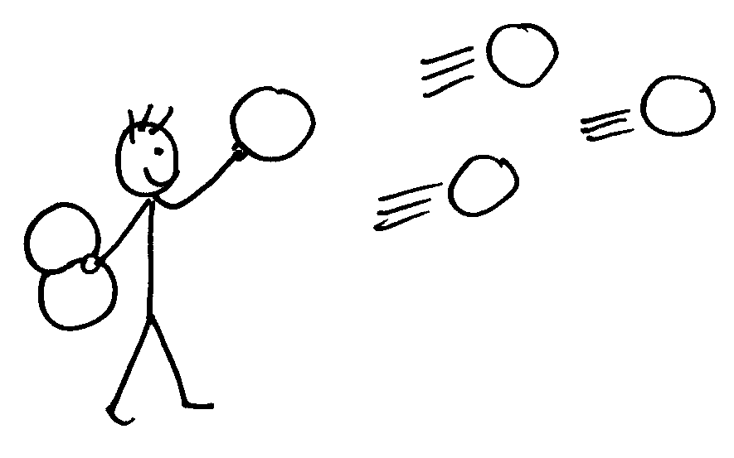 | 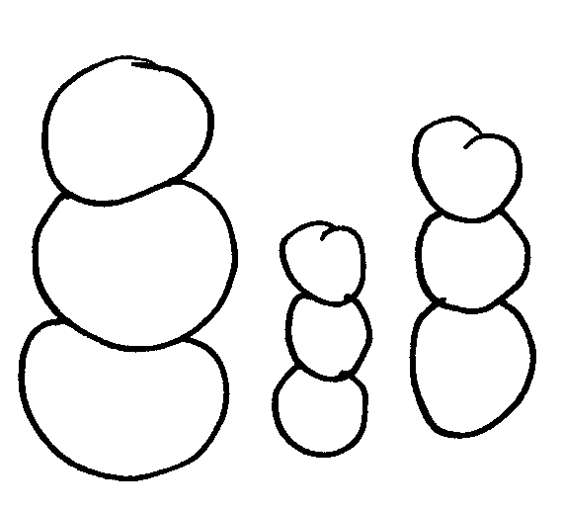  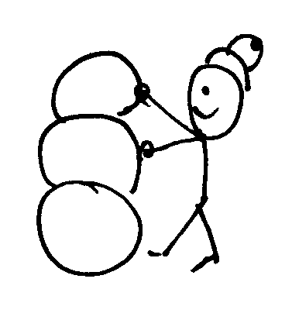
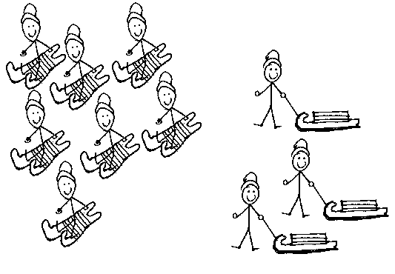 | 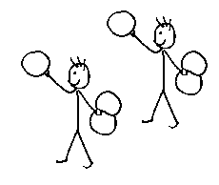
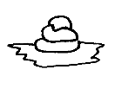 | 