 | Name: | Klasse: | Datum: |  | KV 9
 | Lösungsblatt Bildsachaufgaben (Station 5)

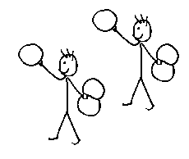 | 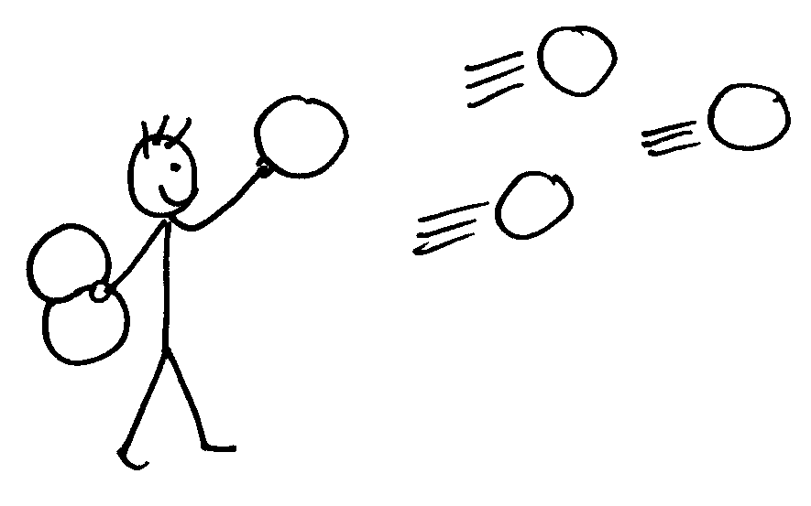
3 + 3 = 6 | 6 – 3 = 3
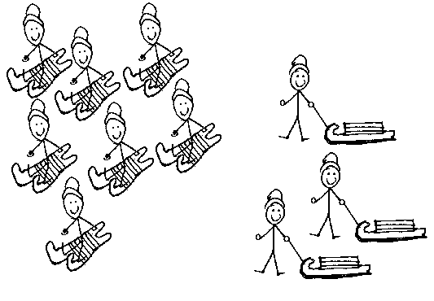 | 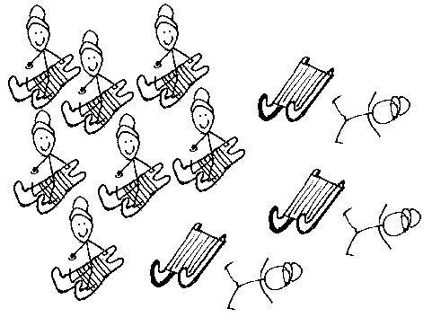
7 + 3 = 10 | 10 – 3 = 7

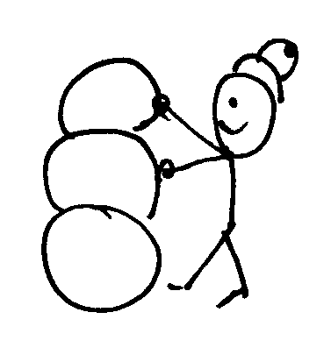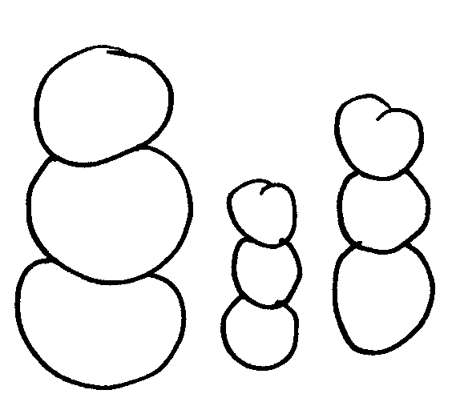 | 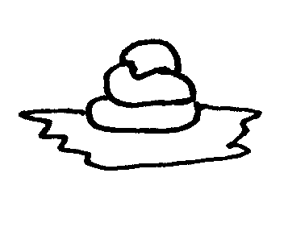
9 + 3 = 12 | 12 – 3 = 9

