 | Name: | Klasse: | Datum: |  | KV 1
Fairy tales – Picture cards

Picture card prince


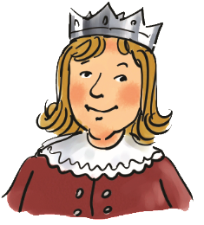
Illustration: Hendrik Kranenberg, Drolshagen

Picture card princess


Illustration: Anke Fröhlich, Leipzig

Picture card king

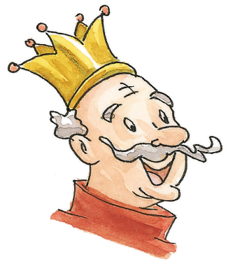
Illustration: Cornelia Haas, Münster

Picture card queen

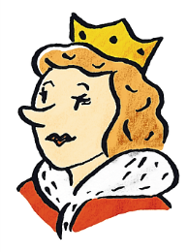
Illustration: Anke Fröhlich, Leipzig

Picture card fairy


Illustration: Hendrik Kranenberg, Drolshagen

Picture card witch

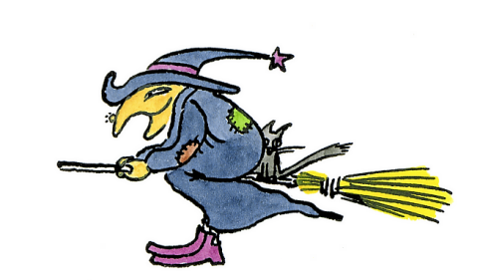
Illustration: Friederike Ablang, Berlin

Picture card frog


Illustration: Friederike Ablang, Berlin

Picture card Puss in Boots

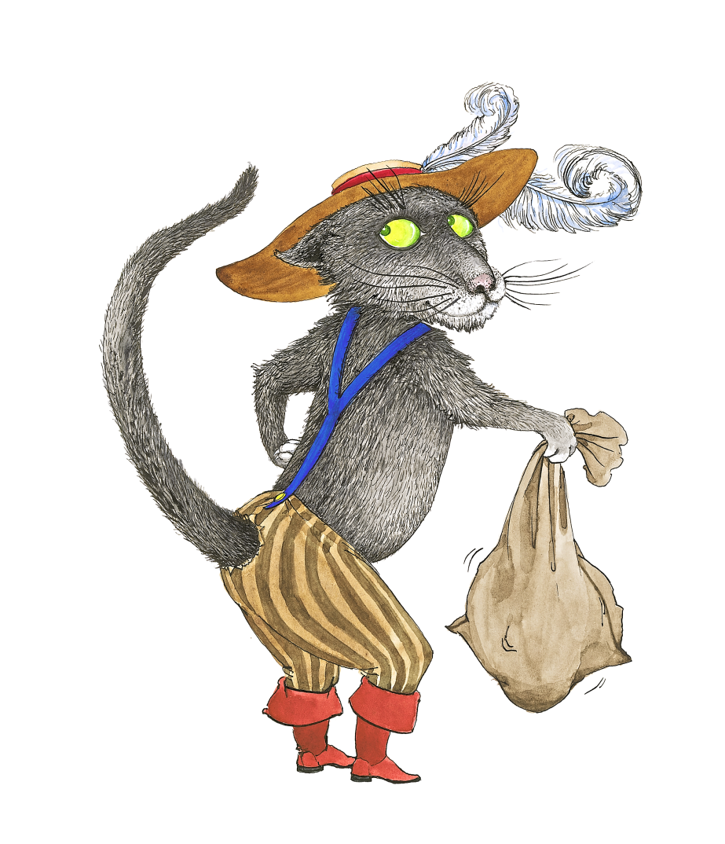
Illustration: Jusche Fret, Leizig

Picture card Little Red Riding Hood

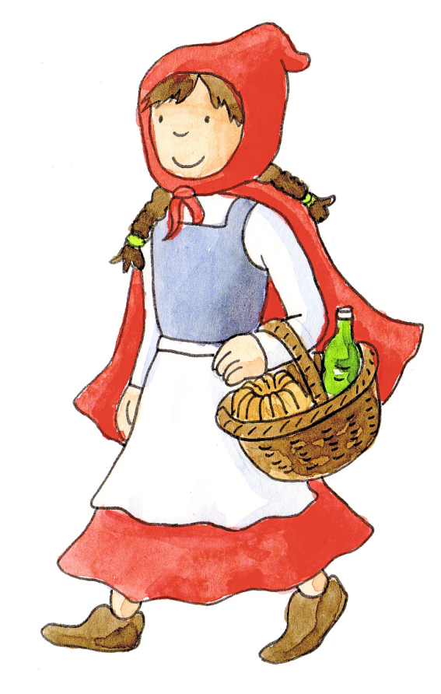
Illustration: Carmen Hochmann, Bielefeld

Picture card wolf

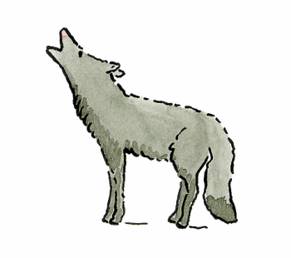
Illustration: Friederike Ablang, Berlin

Picture card pig

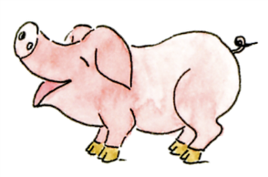
Illustration: Friederike Ablang, Berlin

Picture card Gingerbread Man


Illustration: Fotolia.com (pegasosart)

