 | Name: | Klasse: | Datum: |  | KV 01
Autumn – Colourful leaves

1
My words

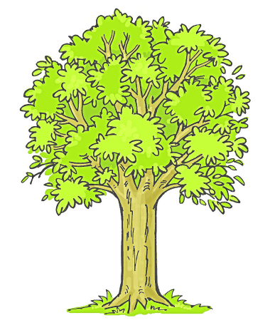 | 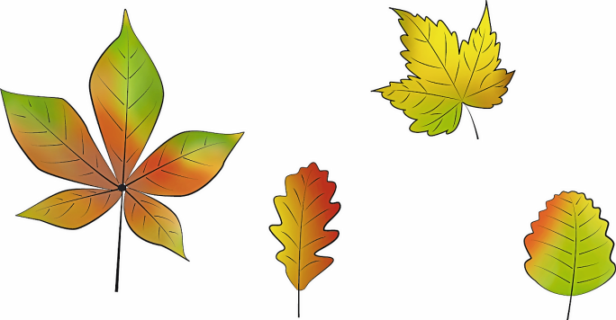
  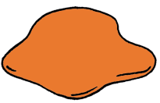  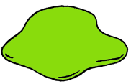  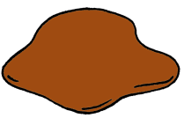  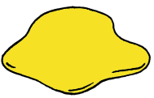 | 
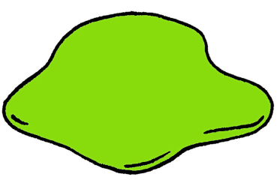 | 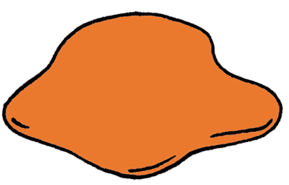
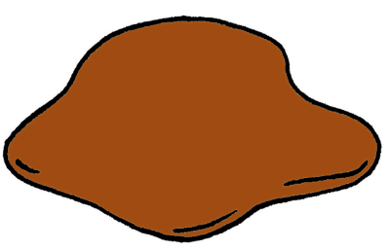 | 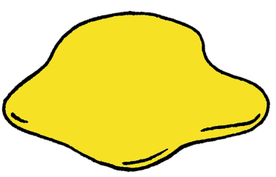

2
Listen. Colour the leaves.



You need: coloured pencils in red, green, yellow, orange and brown.
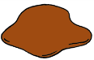


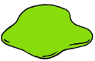




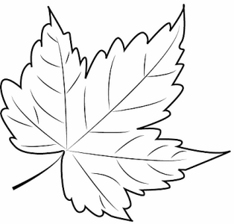

1 | 2 | 3 | 4
__________________ | __________________ | __________________ | __________________
5 | 6 | 7 | 8
__________________ | __________________ | __________________ | __________________

3
Talk to your partner.


What’s your favourite colour?
My favourite colour is …

