 | Name: | Klasse: | Datum: |  | KV 01
Summer – The summer camp

1
My words

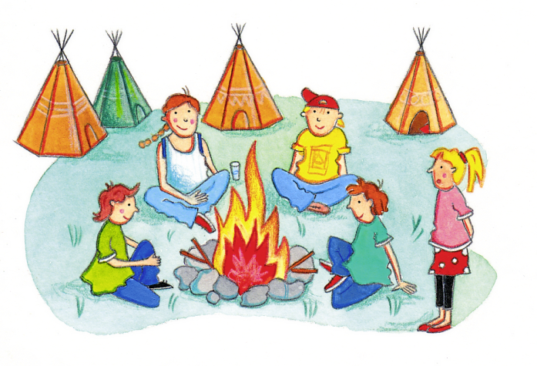 | 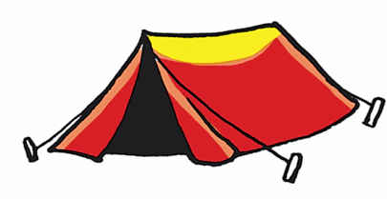
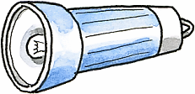 | 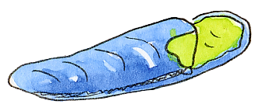
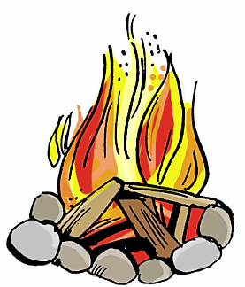 | 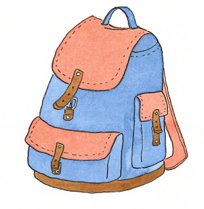
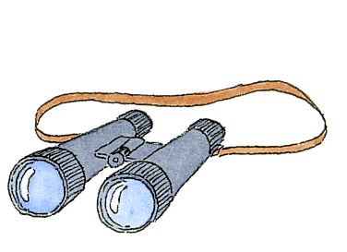 | 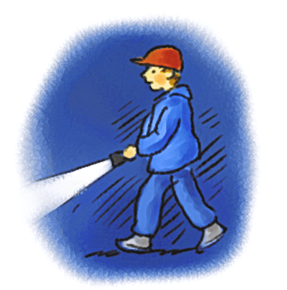
2
Listening text


Join our sunny summer camp! You’ll have to take your tent, your sleeping bag, your rucksack, your binoculars and your torch. Enjoy the campfire or risk a night walk. Interested?

3
Listen and fill in the numbers. Write.


summer camp, tent, torch, sleeping bag, campfire, rucksack, binoculars, night walk



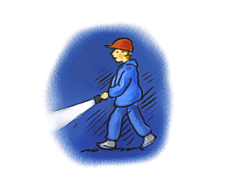 | 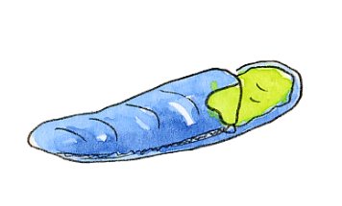 | 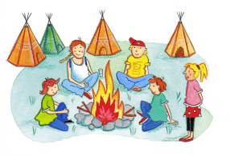 | 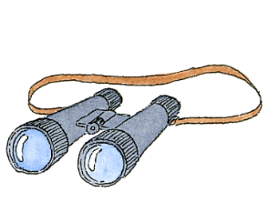
__________________ | __________________ | __________________ | __________________
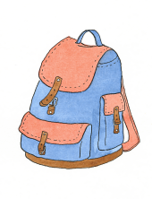 | 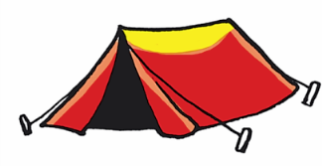 | 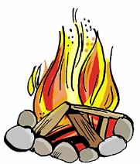 | 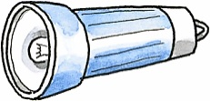
__________________ | __________________ | __________________ | __________________

4
Talk to your partner.


Have you ever been to a summer camp? Did you like it? Talk to your friends about it.

