Vocabulary: Listen, point and repeat.
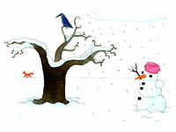  winter | snowflake | 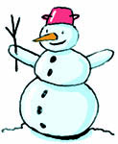  snowman | go by sled
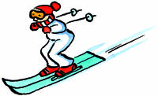  go skiing | 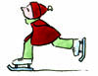  go ice skating | cold | hot chocolate

Story: Listen and point.
Listen and number.
In winter it is cold. | I like to go outside and  watch the snowflakes fall.
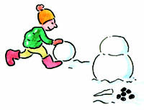  And I love to make a snowman. | Sometimes I go ice-skating or skiing.
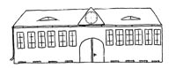  Or I go to school on a sled. | 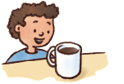  A hot chocolate makes me warm again.

