 | Name: | Klasse: | Datum: |  | KV 1
 | Lesespiel Karten


Ready, set, go!

 |  |   The captain is the boss  of the trip. |   The secretary works in the office of the ship. |  |  | 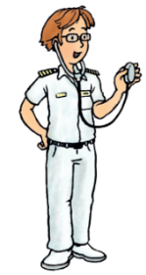  The doctor helps  people who feel bad.
 |  |   The nurse helps with  that. |   The cook in the kitchen  cooks yummy things for you. |  |  |   The baker bakes cakes  and muffins too.
 | Name: |  |  | Klasse: | Datum: |  |  | KV 2
 | Lesespiel Karten

 |  | 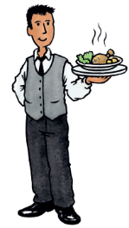  The waiter and the waitress bring you drinks and food. |   No matter what you  wish for, |  |  |   no matter in what  mood.
 |  | 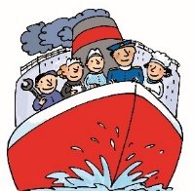  On a ship there´s much  to do. | 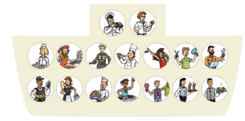  There´s lots of work  for the crew. |  |  | 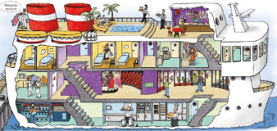  They fix machines, cut,  clean and sell.


They cook and bring
you drinks as well.

 | Name: |  |  | Klasse: | Datum: |  |  | KV 3
 | Lesespiel Karten

 |   The shop assitant sells presents in the shop. |   The haidresser cuts  hair so you look good on top. |  |  |   The DJ plays musical all  night long.
 | On a ship there´s much  to do. | There´s lots of work  for the crew. |  |  | They fix machines, cut,  clean and sell.

They cook and bring
you drinks as well.

 | Name: |  | Klasse: | Datum: |  |  | KV 4
 | Lesespiel Karten

  The singer sings a  special song. |   The engineer fixes  every wire. | 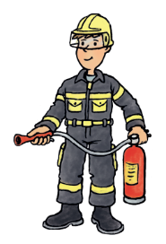  The fire fighter comes  when there´s a fire.
  The cleaner cleans all  the floors. |   The security officer  guards the doors.
On a ship there´s much  to do. | There´s lots of work  for the crew. | They fix machines, cut,  clean and sell.
They cook and bring  you drinks as well. |  |   The end.

