Seite 1 | Name: | Klasse: | Datum: |  | KV 0
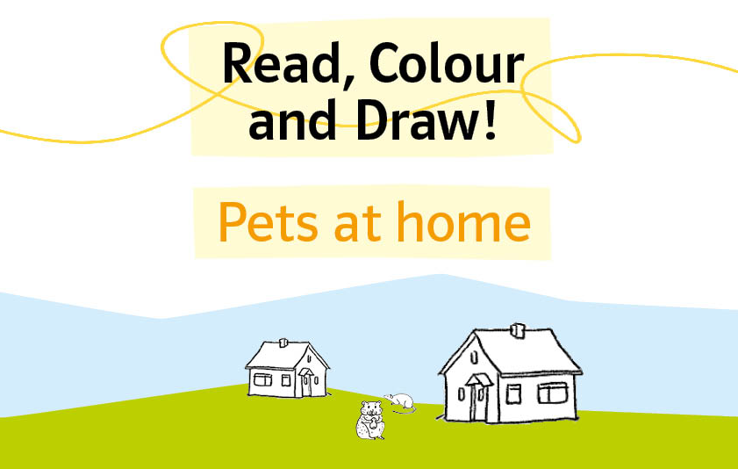

 | Name: | Klasse: | Datum: |  | KV 1

Read, Colour and Draw!

These are Mona and Martin. They are brother and sister.
Mona has got brown hair.
She wears a yellow and green skirt and a red T-Shirt.
Her shoes are black.

Martin has got fair hair. His T-shirt is green and his jeans are blue.
His shoes are black, too. They have got a lot of pets.
Come in and meet them.



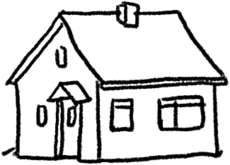

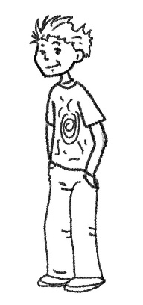
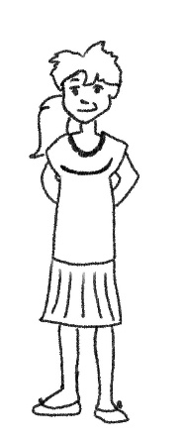

 | Name: | Klasse: | Datum: |  | KV 2

Read, Colour and Draw!
These are Mona‘s and Martin‘s favourite pets.
The rabbit on the left is brown with a white tail.
It is holding a carrot in its paws.
The hamster is a golden hamster. Its colours are white with orange.
The rabbit in the middle is white.
The guinea pig is white and brown. It is eating a small cucumber.

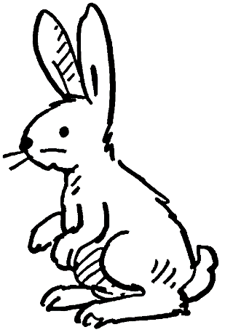

 | Name: | Klasse: | Datum: |  | KV 3

Read, Colour and Draw!
There is a yellow table. There is a grey cage is on the table.
Martin’s budgies are missing.
Martin calls: “Budgie, where are you?“

Maybe his black cat can help him find it.

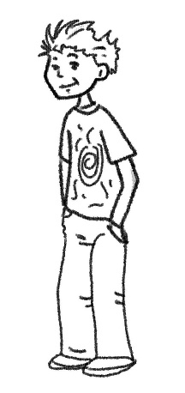

 | Name: | Klasse: | Datum: |  | KV 4

Read, Colour and Draw!
The big cat is black with white paws. It is looking up the pear tree.
The pears are light green and yellow.

The small cat is red with white paws. It is looking up the apple tree.
There is a blue and a yellow budgie. On the tree, there are five red apples.

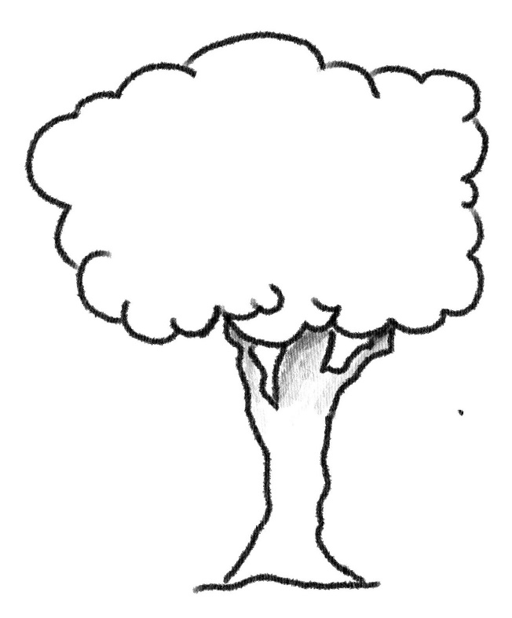

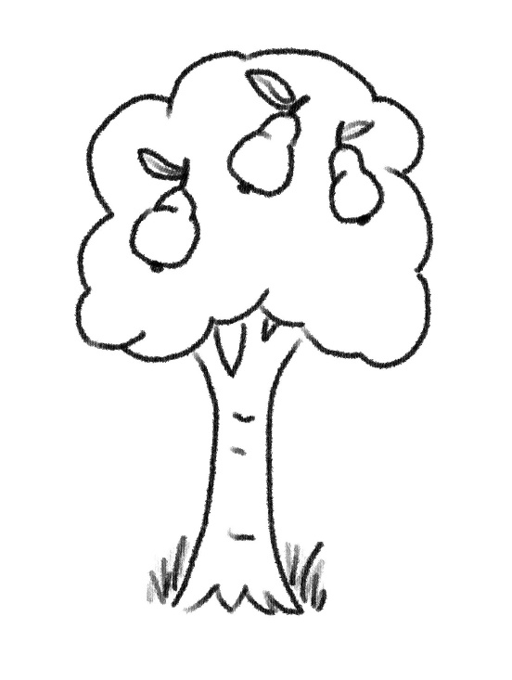

 | Name: | Klasse: | Datum: |  | KV 5

Read, Colour and Draw!
The cats have found the budgie. They are very proud.
The budgie is flying back with the cats.

The budgie is very beautiful. It is blue and yellow.
The small cat is red with white paws.

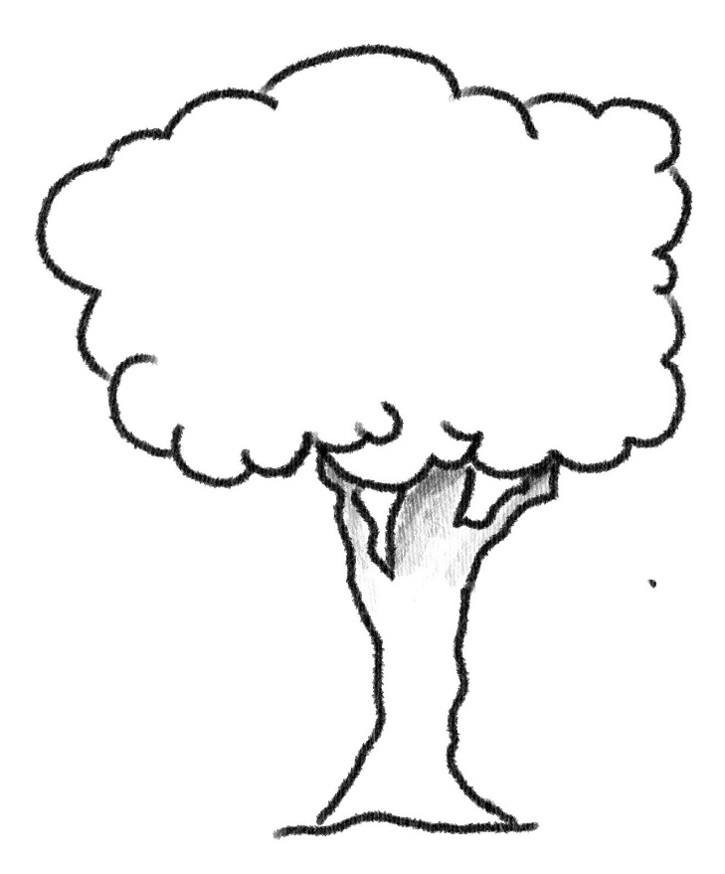

 | Name: | Klasse: | Datum: |  | KV 6

Read, Colour and Draw!
The blue and yellow budgie sits on the cage.
The vase is yellow with a pink flower in it.

 | Name: | Klasse: | Datum: |  | KV 7

Read, Colour and Draw!
In the kitchen, there are three white and grey rabbits.
They want the ten carrots on the orange table.

Maybe their friend cat can help?
The cat is red with white paws.

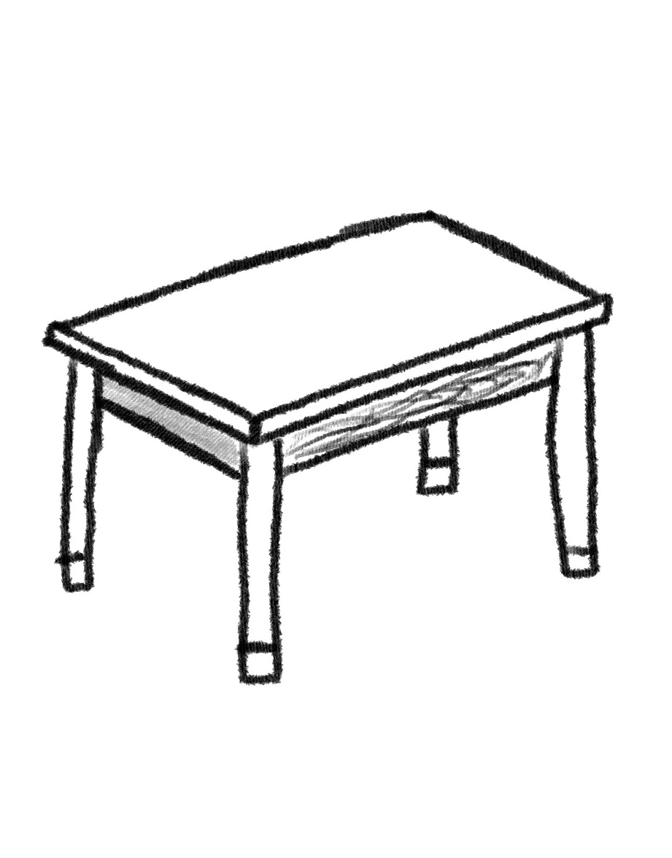
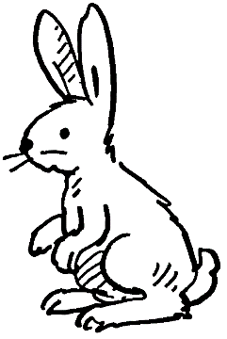
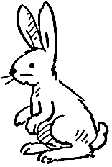
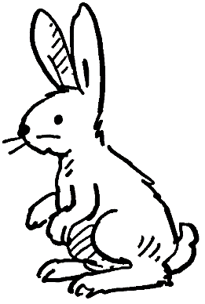

 | Name: | Klasse: | Datum: |  | KV 8

Read, Colour and Draw!
There are two cats next to the brown table.
One cat is red and the other cat is black with white stripes.

They can smell the rabbit.
The rabbit is white. In front of the rabbit there is an orange carrot.

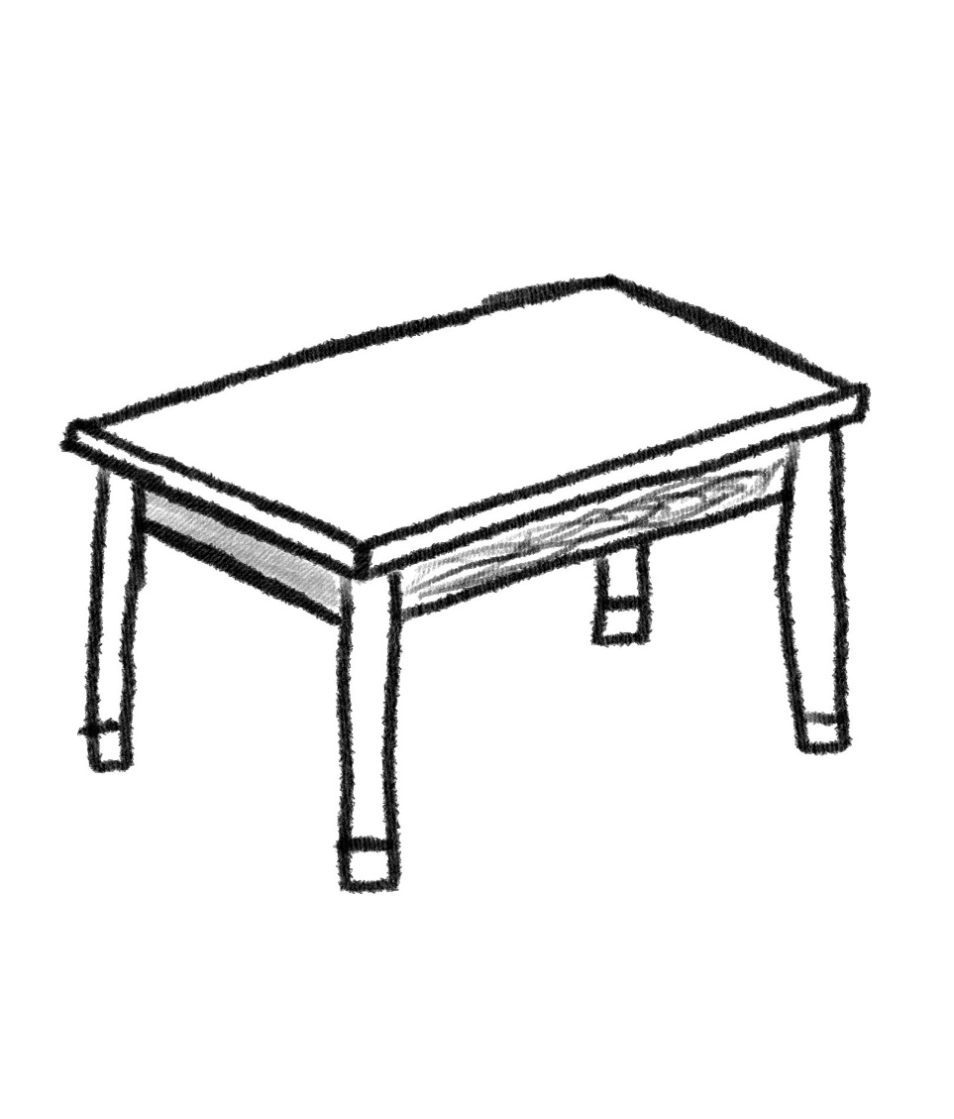

 | Name: | Klasse: | Datum: |  | KV 9

Read, Colour and Draw!
The black cat is sitting on a brown chair.
There are two sausages under the chair.

The dogs want the sausages. The dog on the right is dark brown.
The other dog is white with many black spots.

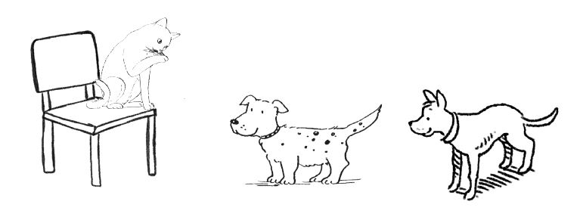
 | Name: | Klasse: | Datum: |  | KV 10

Read, Colour and Draw!
There are two guinea pigs in the picture.
One brown guinea pig is taking a bath in Bello’s bowl.
The other guinea pig is watching its friend. It is white and brown.

The bowl is yellow.
Bello, the dog, is black. Bello and the guinea pigs are friends.

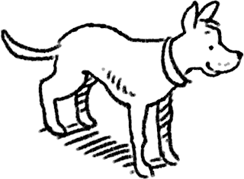
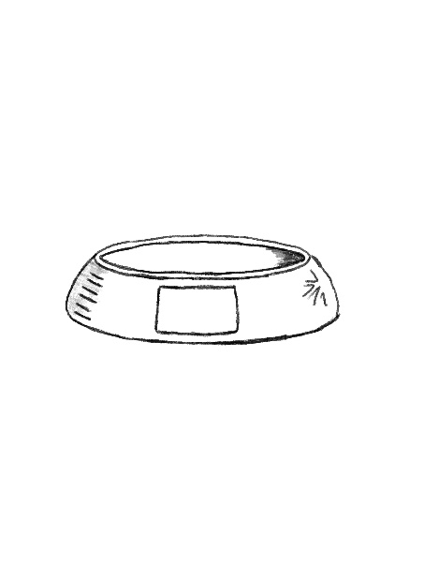
Bello
 | Name: | Klasse: | Datum: |  | KV 11

Read, Colour and Draw!
These are Mona and Martin again.
They love all their pets, but their favourite ones are sitting on the sofa.

It’s the red cat with white paws and the white dog with black spots.
The sofa is blue.

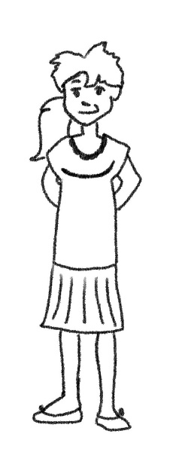
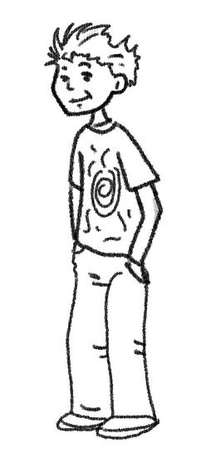
 | Name: | Klasse: | Datum: |  | KV 12

Read, Colour and Draw!
Some pets are in the living room. The golden hamster is sitting on a blue sofa.The hamster is white with orange. It is eating a brown nut.

Under the blue armchair, there is a brown and green tortoise.
It is looking for its baby. The baby tortoise is on the armchair.
It is green and yellow.

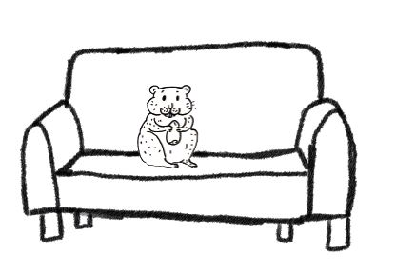
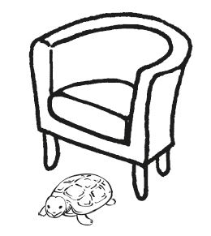

 | Name: | Klasse: | Datum: |  | KV 13

Read, Colour and Draw!
The red cat is sitting on a yellow chair.
It can’t see the rat under the brown table.

The rat is grey. But watch out, rat!
There is another cat next to the table. This cat is black.

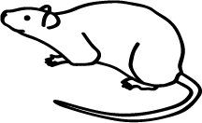
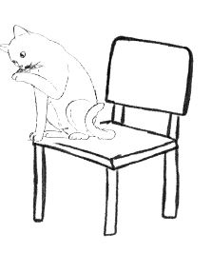
 | Name: | Klasse: | Datum: |  | KV 14

Read, Colour and Draw!
There are three rats on the shelf.
One is white and the other two are brown.

There are two more rats under the blue sofa.
They are white too.

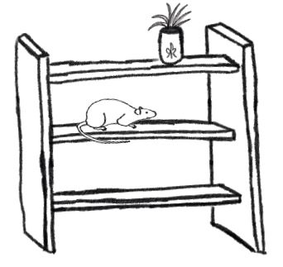
 | Name: | Klasse: | Datum: |  | KV 15

Read, Colour and Draw!
The rat in the pink shelf is grey.
The bed is pink too, with yellow sheets.

There is a purple carpet in front of the bed.
It must be Mona’s bedroom because she likes pink a lot.

 | Name: | Klasse: | Datum: |  | KV 16

Read, Colour and Draw!
This is Martin‘s bedroom. The bed is blue with yellow sheets.
The rat on the bed is white with black spots.

Next to the bed, there is a black hat with another rat.

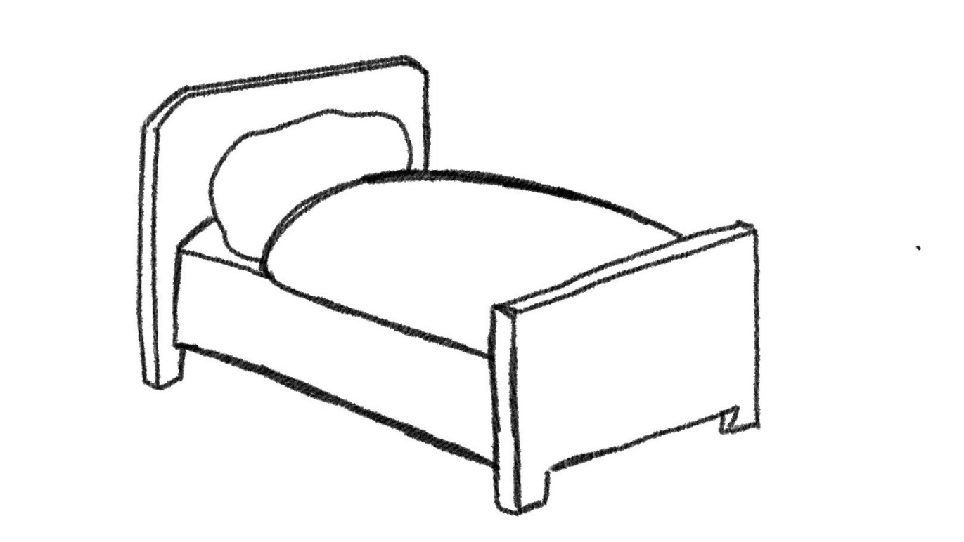
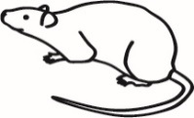
 | Name: | Klasse: | Datum: |  | KV 17

Read, Colour and Draw!
In the tank, there are five fish.
Four fish are best friends. They are orange.

The other fish is different! It is very beautiful and colourful.
Its colours are yellow, green, blue and purple.
It is looking for a friend. Can you draw a friend for him?

 | Name: | Klasse: | Datum: |  | KV 18

Read, Colour and Draw!
It is a sunny day. There is only one cloud in the sky.
There are two brown and two white dogs in front of the house.
They are looking for the cat.

The red cat is on the black roof of the house.
The walls of the house are yellow.

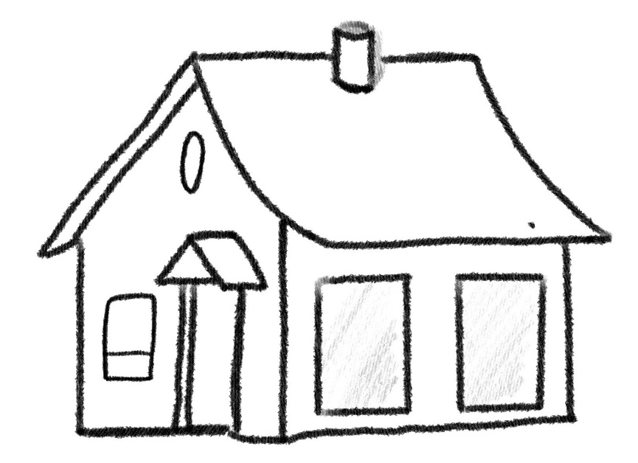

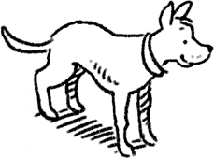
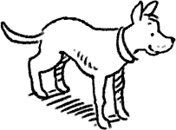
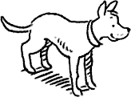
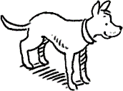
 | Name: | Klasse: | Datum: |  | KV 19

Read, Colour and Draw!
There are lots of apple trees in the garden.
The biggest tree on the left carries 15 red apples.
Sometimes the dogs play football with the apples.

The dog on the right is dark brown.
The dog on the left is white with black spots.

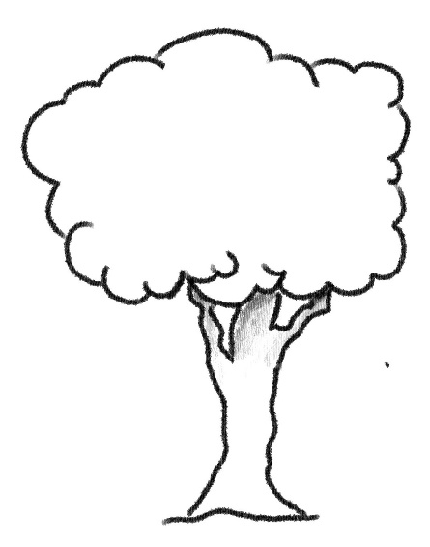
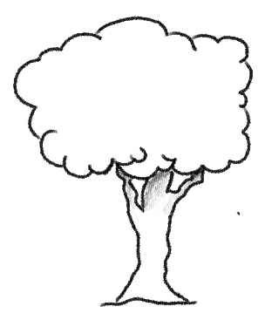
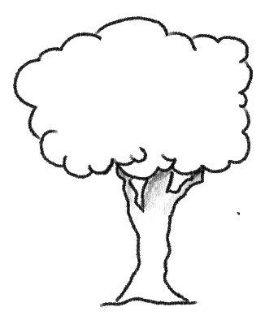
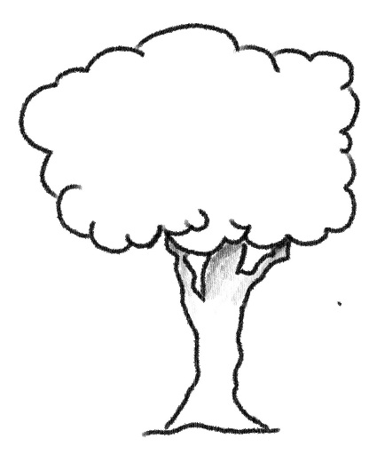
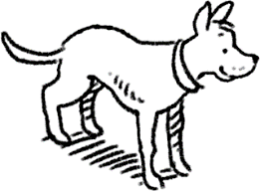
 | Name: | Klasse: | Datum: |  | KV 20

Read, Colour and Draw!

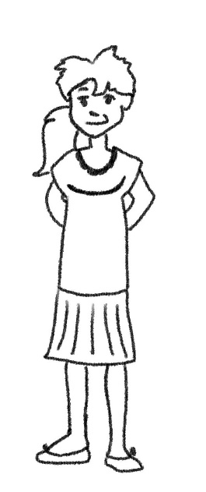
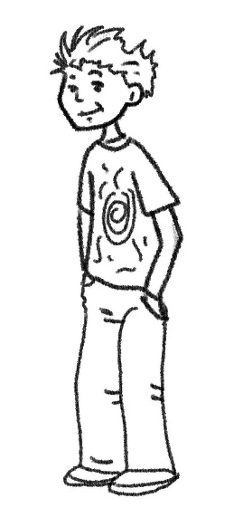
What is your favourite pet?

