 | Name: | Klasse: | Datum: |  | KV 95
 | Lernzielkontrolle 5A Seite 1 erreichte Punktzahl:

1


 |  | 14 |  |  | – | 5 |  |  | = | 9 |  |  |  |  |  | 16 |  |  | – | 8 |  |  | = | 8
 | 14 |  | – | 4 |  |  | – | 1 |  |  |  |  |  |  | 16 |  | – | 6 |  |  | – | 2

 |  | 13 |  |  | – | 9 |  |  | = | 4 |  |  |  |  |  | 17 |  |  | – | 8 |  |  | = | 9
 | 13 |  | – | 3 |  |  | – | 6 |  |  |  |  |  |  | 17 |  | – | 7 |  |  | – | 1

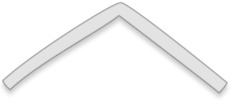

2
 |  |  |  |  | 9 |  |  |  |  |  |  |  |  |  |  |  |  |  |  |  |  |  |  |  |  |  |  |  |  |  |  |  |  |  |  |  | 15
 |  | 6 |  |  |  |  | 3 |  |  |  |  |  |  |  |  |  |  |  |  |  |  |  |  |  |  |  |  |  |  |  |  |  |  | 8 |  |  |  |  | 7
 | 6 |  | + | 3 |  | = |  | 3 |  |  |  |  |  | 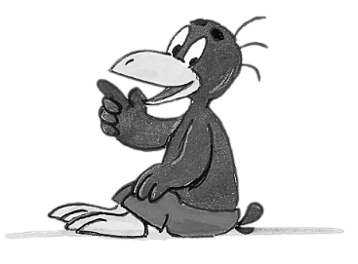 |  |  |  |  |  |  |  |  |  |  |  |  |  |  |  |  |  | 8 |  |  | + | 7 |  | = |  | 15
 | 3 |  | + | 6 |  | = |  | 9 |  |  |  |  |  |  |  |  |  |  |  |  |  |  |  |  |  |  |  |  |  |  |  | 7 |  |  | + | 8 |  | = |  | 15
 | 9 |  | – | 3 |  | = |  | 6 |  |  |  |  |  |  |  |  |  |  |  |  |  |  |  |  |  |  |  |  |  |  |  | 15 |  |  | – | 7 |  | = |  | 8
 | 9 |  | – | 6 |  | = |  | 3 |  |  |  |  |  |  |  |  |  |  |  |  |  |  |  |  |  |  |  |  |  |  |  | 15 |  |  | – | 8 |  | = |  | 7

3
 |  |  |  | 4 |  | + |  | 4 |  | = |  | 8 |  |  |  |  |  |  |  |  |  | 7 |  | + |  | 7 |  | = |  | 14

 |  |  |  | 9 |  | + |  | 9 |  | = |  | 18 |  |  |  |  |  |  |  |  |  | 6 |  | + |  | 6 |  | = |  | 12

 | Name: | Klasse: | Datum: |  | KV 95
 | Lernzielkontrolle 5A Seite 2 erreichte Punktzahl:
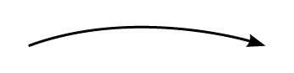
4
=
>
<
4
=
>
<
4
=
>
<
4
=
>
<
4
 | + ____ |  | + ____  4  =  >  < |  | + ____ | + ____ | + ____
0 |  |  |  | 4 |  |  |  | 8 |  |  |  | 12 |  |  |  | 16 |  |  |  | 20
4
=
>
<
4
=
>
<
4
=
>
<
4
=
>
<
 |  | – ____ | – | ____ | – ____ | – ____

0 |  |  | 3 |  |  |  | 7 |  |  |  | 11 |  |  |  | 15 |  |  |  | 19 | 20

5
8 | + | 3 | = | 11 |  | 19 | – | 5 | = | 14 |  | 11 | + | 0 | = | 11
8 | + | 4 | = | 12 |  | 17 | – | 5 | = | 12 |  | 11 | + | 2 | = | 13
8 | + | 5 | = | 13 |  | 15 | – | 5 | = | 10 |  | 11 | + | 4 | = | 15
8 | + | 6 | = | 14 |  | 13 | – | 5 | = | 8 |  | 11 | + | 6 | = | 17
8 | + | 7 | = | 15 |  | 11 | – | 5 | = | 6 |  | 11 | + | 8 | = | 19
8 | + | 8 | = | 16 |  | 9 | – | 5 | = | 4 |  | 11 | + | 10 | = | 21


6
Setze <, >, = ein.

5 | + | 3 | <  =  >  < | 9 |  |  |  | 17 | – | 6 |  | 12 |  |  |  | 12 | <  =  >  < | 6 | + | 8
12 | + | 5 | >  =  >  < | 16 |  |  |  | 14 | – | 3 | >  =  >  <  <  =  >  < | 8 |  |  |  | 19 | =  =  >  < | 13 | + | 6

8
7
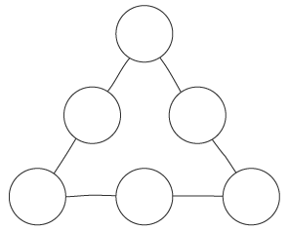
4
6

2
9
1
7
Zauberzahl 12
 |  |  |  |  | 12
 |  | 7 |  |  |  |  | 5
 | 7 |  | + | 5 |  | = |  | 12
 | 5 |  | + | 7 |  | = |  | 12
 | 12 |  | – | 5 |  | = |  | 7
 | 12 |  | – | 7 |  | = |  | 5

