 | Name: | Klasse: | Datum: |  | KV 96
 | Lernzielkontrolle 5B Seite 1 erreichte Punktzahl:

1


 |  | 17 |  |  | – | 8 |  |  | = |  |  |  |  |  |  | 15 |  |  | – | 7 |  |  | =
 |  |  | – |  |  |  | – |  |  |  |  |  |  |  |  |  | – |  |  |  | –

 |  | 16 |  |  | – | 9 |  |  | = |  |  |  |  |  |  | 12 |  |  | – | 7 |  |  | =
 |  |  | – |  |  |  | – |  |  |  |  |  |  |  |  |  | – |  |  |  | –

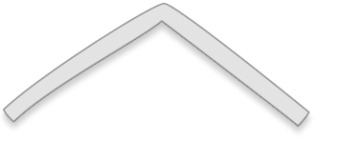

2
 |  |  |  |  | 7 |  |  |  |  |  |  |  |  |  |  |  |  |  |  |  |  |  |  |  |  |  |  |  |  |  |  |  |  |  |  |  | 13
 |  | 3 |  |  |  |  | 4 |  |  |  |  |  |  |  |  |  |  |  |  |  |  |  |  |  |  |  |  |  |  |  |  |  |  | 7 |  |  |  |  | 6
 | 3 |  | + | 4 |  | = |  |  |  |  |  |  |  | 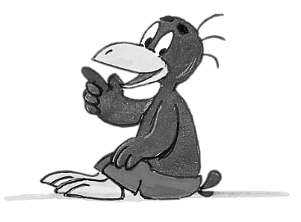 |  |  |  |  |  |  |  |  |  |  |  |  |  |  |  |  |  |  |  |  | + |  |  | =
 |  |  | + |  |  | = |  |  |  |  |  |  |  |  |  |  |  |  |  |  |  |  |  |  |  |  |  |  |  |  |  |  |  |  | + |  |  | =
 | 7 |  | – | 4 |  | = |  |  |  |  |  |  |  |  |  |  |  |  |  |  |  |  |  |  |  |  |  |  |  |  |  |  |  |  | – |  |  | =
 |  |  | – |  |  | = |  |  |  |  |  |  |  |  |  |  |  |  |  |  |  |  |  |  |  |  |  |  |  |  |  |  |  |  | – |  |  | =

3
 |  |  |  | 5 |  | + |  | 5 |  | = |  |  |  |  |  |  |  |  |  |  |  |  |  | + |  |  |  | =

 |  |  |  |  |  | + |  |  |  | = |  |  |  |  |  |  |  |  |  |  |  | 8 |  | + |  |  |  | =

 | Name: | Klasse: | Datum: |  | KV 96
 | Lernzielkontrolle 5B Seite 2 erreichte Punktzahl:
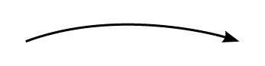
4
 | + ____ | + ____
0 |  |  |  |  |  | 6 |  |  |  |  |  |  |  |  |  |  |  |  |  | 20

– ____

0 |  |  |  |  |  |  |  |  |  |  |  |  | 13 |  |  |  |  |  | 19 | 20

5
7 | + | 3 | = |  |  | 18 | – | 5 | = |  |  | 11 | + | 0 | =
7 | + | 4 | = |  |  | 16 | – | 5 | = |  |  | 11 | + | 2 | =
7 | + | 5 | = |  |  | 14 | – | 5 | = |  |  | 11 | + | 4 | =
7 | + |  | = |  |  |  | – |  | = |  |  |  | + |  | =+
7 | + |  | = |  |  |  | – |  | = |  |  |  | + |  | =
7 | + |  | = |  |  |  | – |  | = |  |  |  | + |  | =


6
Setze <, >, = ein.

2 | + | 4 |  | 7 |  |  |  | 15 | – | 3 |  | 11 |  |  |  | 12 |  | 7 | + | 6
12 | + | 7 |  | 16 |  |  |  | 14 | – | 5 |  | 8 |  |  |  | 19 |  | 13 | + | 6

8
7
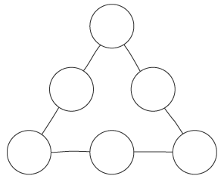
Zauberzahl 12

3

1

6
 |  |  | + |  |  | =
 |  |  | + |  |  | =
 | 15 |  | – | 6 |  | =
 |  |  | – |  |  | =

