 | Name: | Klasse: | Datum: |  | KV 96
 | Lernzielkontrolle 5B Seite 1 erreichte Punktzahl:

1


 |  | 17 |  |  | – | 8 |  |  | = | 9 |  |  |  |  |  | 15 |  |  | – | 7 |  |  | = | 8
 | 17 |  | – | 7 |  |  | – | 1 |  |  |  |  |  |  | 15 |  | – | 5 |  |  | – | 2

 |  | 16 |  |  | – | 9 |  |  | = | 7 |  |  |  |  |  | 12 |  |  | – | 7 |  |  | = | 5
 | 16 |  | – | 6 |  |  | – | 3 |  |  |  |  |  |  | 12 |  | – | 2 |  |  | – | 5

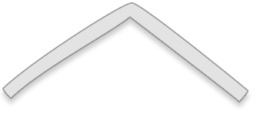

2
 |  |  |  |  | 7 |  |  |  |  |  |  |  |  |  |  |  |  |  |  |  |  |  |  |  |  |  |  |  |  |  |  |  |  |  |  |  | 13
 |  | 3 |  |  |  |  | 4 |  |  |  |  |  |  |  |  |  |  |  |  |  |  |  |  |  |  |  |  |  |  |  |  |  |  | 7 |  |  |  |  | 6
 | 3 |  | + | 4 |  | = |  | 7 |  |  |  |  |  | 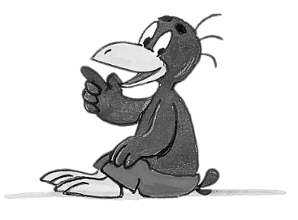 |  |  |  |  |  |  |  |  |  |  |  |  |  |  |  |  |  | 7 |  |  | + | 6 |  | = |  | 13
 | 4 |  | + | 3 |  | = |  | 7 |  |  |  |  |  |  |  |  |  |  |  |  |  |  |  |  |  |  |  |  |  |  |  | 6 |  |  | + | 7 |  | = |  | 13
 | 7 |  | – | 4 |  | = |  | 3 |  |  |  |  |  |  |  |  |  |  |  |  |  |  |  |  |  |  |  |  |  |  |  | 13 |  |  | – | 6 |  | = |  | 7
 | 7 |  | – | 3 |  | = |  | 4 |  |  |  |  |  |  |  |  |  |  |  |  |  |  |  |  |  |  |  |  |  |  |  | 13 |  |  | – | 7 |  | = |  | 6

3
 |  |  |  | 5 |  | + |  | 5 |  | = |  | 10 |  |  |  |  |  |  |  |  |  | 9 |  | + |  | 9 |  | = |  | 18

 |  |  |  | 7 |  | + |  | 7 |  | = |  | 14 |  |  |  |  |  |  |  |  |  | 8 |  | + |  | 8 |  | = |  | 16

 | Name: | Klasse: | Datum: |  | KV 96
 | Lernzielkontrolle 5B Seite 2 erreichte Punktzahl:
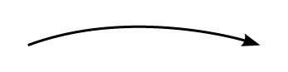
6
=
>
<
6
=
>
<
6
=
>
<
4
 | + ____ | + ____ |  | + ____
0 |  |  |  |  |  | 6 |  |  |  |  |  | 12 |  |  |  |  |  | 18 |  | 20
- ____
- ___
=
>
<
6
=
>
<
6
=
>
<
6
=
>
<
 | – ____ |  |  |  | – ____

0 | 1 |  |  |  |  |  | 7 |  |  |  |  |  | 13 |  |  |  |  |  | 19 | 20

5
7 | + | 3 | = | 10 |  | 18 | – | 5 | = | 13 |  | 11 | + | 0 | = | 11
7 | + | 4 | = | 11 |  | 16 | – | 5 | = | 11 |  | 11 | + | 2 | = | 13
7 | + | 5 | = | 12 |  | 14 | – | 5 | = | 9 |  | 11 | + | 4 | = | 15
7 | + | 6 | = | 13 |  | 12 | – | 5 | = | 7 |  | 11 | + | 6 | =+ | 17
7 | + | 7 | = | 14 |  | 10 | – | 5 | = | 5 |  | 11 | + | 8 | = | 19
7 | + | 8 | = | 15 |  | 8 | – | 5 | = | 3 |  | 11 | + | 10 | = | 21


6
Setze <, >, = ein.

2 | + | 4 | <  =  >  < | 7 |  |  |  | 15 | – | 3 | >  =  >  < | 11 |  |  |  | 12 | <  =  >  < | 7 | + | 6
12 | + | 7 | >  =  >  < | 16 |  |  |  | 14 | – | 5 | >  =  >  < | 8 |  |  |  | 19 | =  =  >  < | 13 | + | 6

8
7
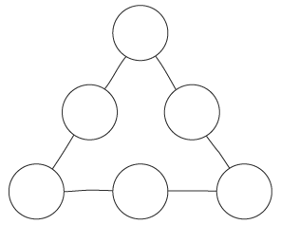
Zauberzahl 12
2
3

7
1
4
6
 |  |  |  |  | 15
 |  | 9 |  |  |  |  | 6
 | 9 |  | + | 6 |  | = |  | 15
 | 6 |  | + | 9 |  | = |  | 15
 | 15 |  | – | 6 |  | = |  | 9
 | 15 |  | – | 9 |  | = |  | 6

