 | Name: | Klasse: | Datum: |  | KV 03
Mein Tausenderbuch

So sieht mein Tausenderbuch aus:

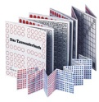

Das habe ich entdeckt:
_________________________________________________________________________
_________________________________________________________________________
_________________________________________________________________________
_________________________________________________________________________
_________________________________________________________________________
_________________________________________________________________________
_________________________________________________________________________

Diese Fragen habe ich dazu:
_________________________________________________________________________
_________________________________________________________________________
_________________________________________________________________________
_________________________________________________________________________
_________________________________________________________________________

