 | Name | Klasse | Datum | 
Bat garland
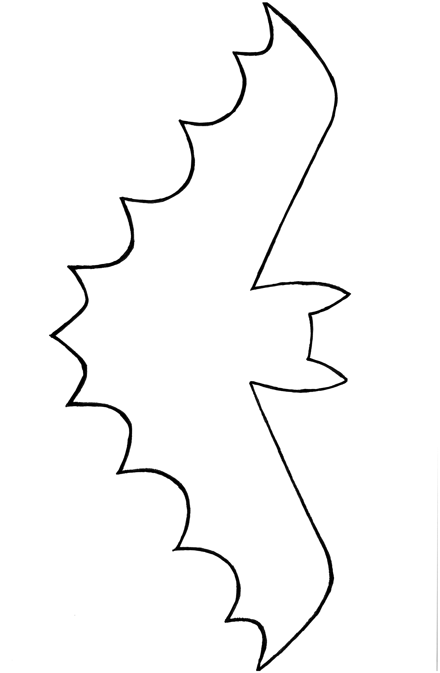
1

Cut out and make a garland.

