 | name: | class: | date:
Easter card

1



Make an Easter card.




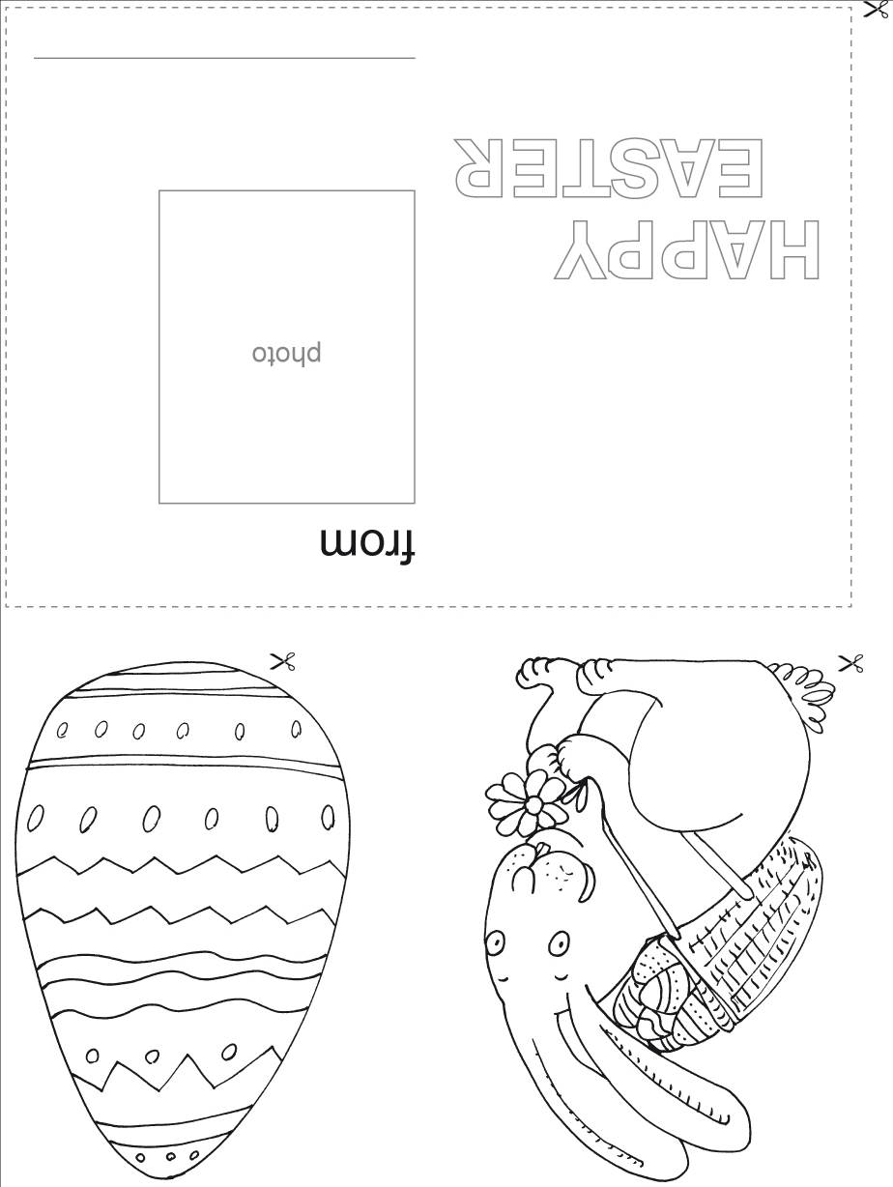
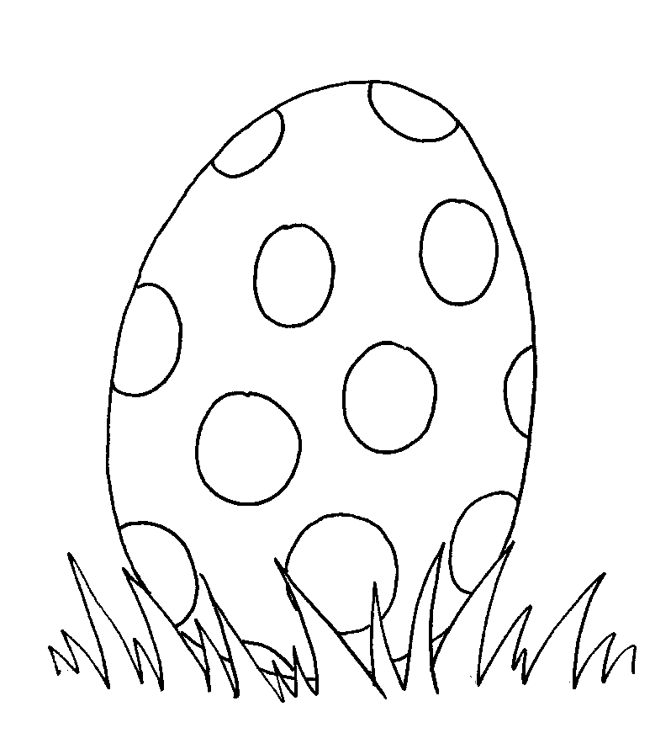

Dear ________________________.

I wish a

“__________ ________________”

especially to you.

Yours, ________________________.

fold
cut

